

Jan 9, 2024

One way of reducing the effects of climate change is to reduce the emissions of greenhouse gases. The most common greenhouse gas is CO2. CO2 is an unavoidable product of the combustion of fossil fuels, including LPG and coal, and biomass, including wood and charcoal. Many people in developing countries burn wood for cooking. When a cook utilizes a cookstove that is more fuel efficient than her previous technology she has reduced her households emissions of CO2. Careful accounting of greenhouse gas emissions reductions generates carbon credits which can be sold to greenhouse gas emitters.

Carbon credit developers use various measurement to determine the greenhouse gas emissions reductions of users of wood burning stoves in developing countries. Under the AMS-II.G[1], carbon credit developers choose the Kitchen Performance Test (KPT)[2] to form an initial assessment of the household fuel savings that is accomplished when a household transitions from a traditional cookstove to a fuel efficient cookstove. The methodology uses the following equation to measure yearly emissions reductions:

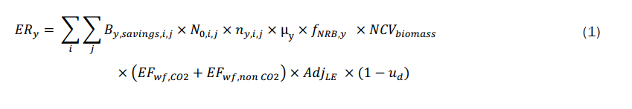

where



The KPT directly measures the amount of fuel used by a household. KPT can be done on the project and baseline stoves in order to calculate daily project fuel savings By,savings,i,j on an individual household basis. Since each household consumes a different amount of fuel, and fuel consumption varies per day, a KPT must be performed in multiple households over multiple days. The test is typically done over three days and, according to AMS-II.G., “when the project proponent chooses to inspect annually, a 90 per cent confidence interval and a 10 per cent margin of error shall be achieved for the sampled parameters.”

The following page from Theory and Design for Mechanical Measurements, 3rd Edition, by Figliola and Beasley, shows the math which can be used to calculate the mean daily household fuel consumption, and its standard deviation which are needed to calculate the 90% confidence interval of the mean. When the data are considered to be structured with M test replicates each with N repetitions (M households, each with N days of measurements) the mean daily fuel consumption is calculated according to Eq. 4.19. The pooled standard deviated is calculated according to Eq. 4.20. When the number of repetitions is not equal between the replicates, Eq. 22 and 23 are used.

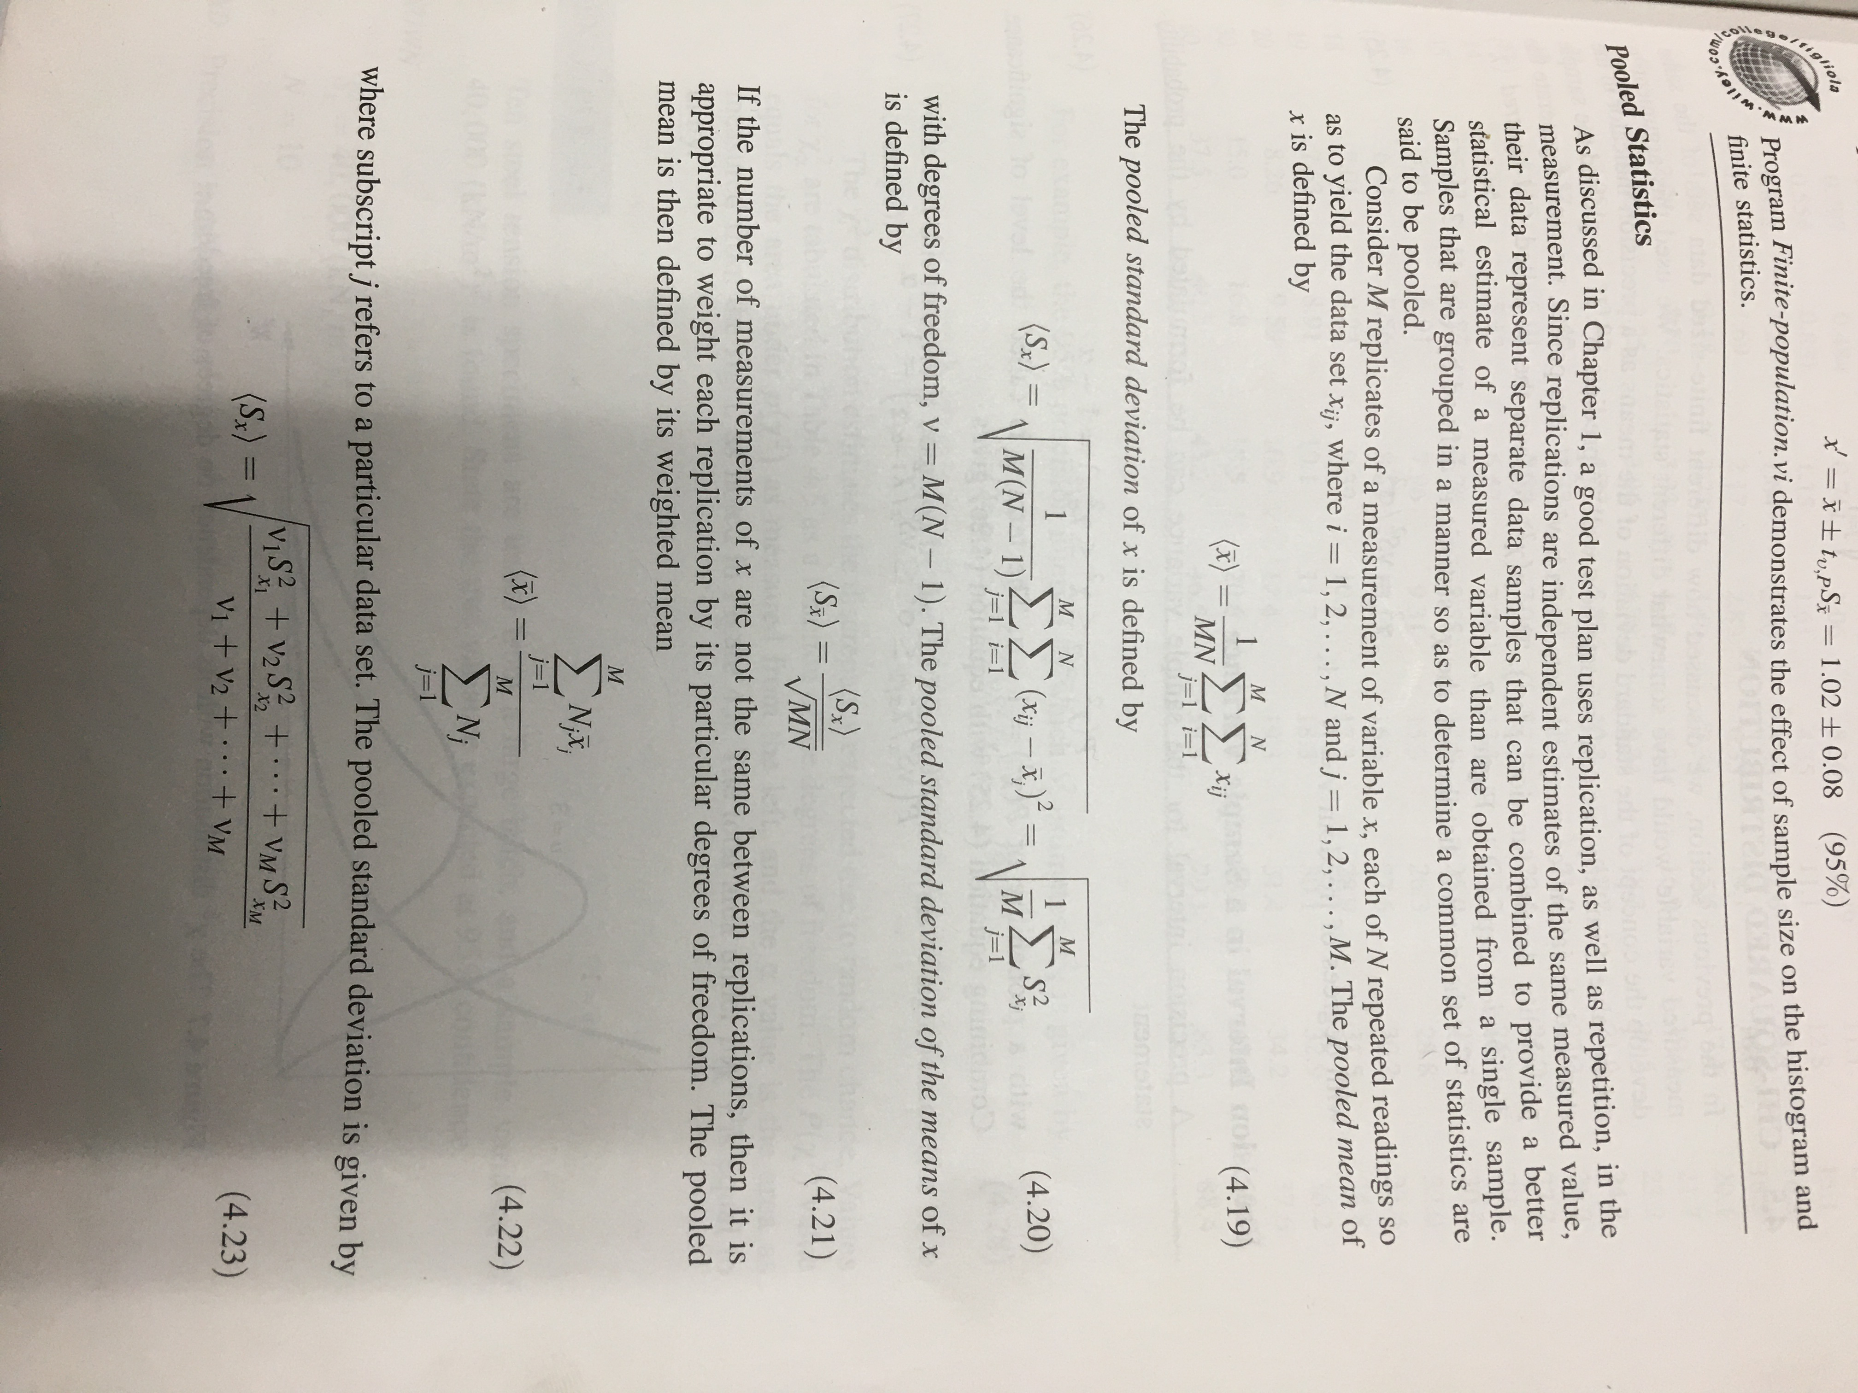

1. Clean Development Mechanism, AMS-II.G. “Small Scale Methodology – Energy efficiency measures in thermal application of non-renewable biomass” Ver. 12
2. KPT Version 4, 2018 (https://cleancooking.org/binary-data/DOCUMENT/file/000/000/604-1.pdf)